**Experiment - 4**

**Aim: list of all student from student table.**

create table student (

name varchar (20),

rollno varchar (20),

age int);

insert into student

values ('mukesh',4,5);

select * from student;

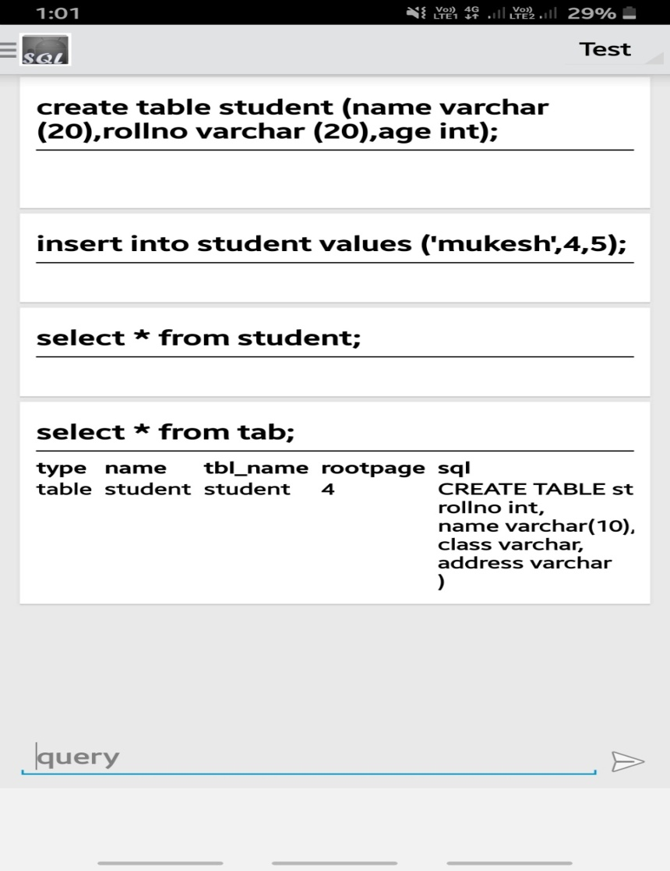**OUTPUT-**

